M.S.KIRUBA KARTHIK 192472004
JAVA PROGRAMMING
DR.S.PADMAKALA
FLOWGORITHM
- Read a person&#39;s pulse rate and age group. Display Normal or Abnormal based on different acceptable ranges for children and adults.
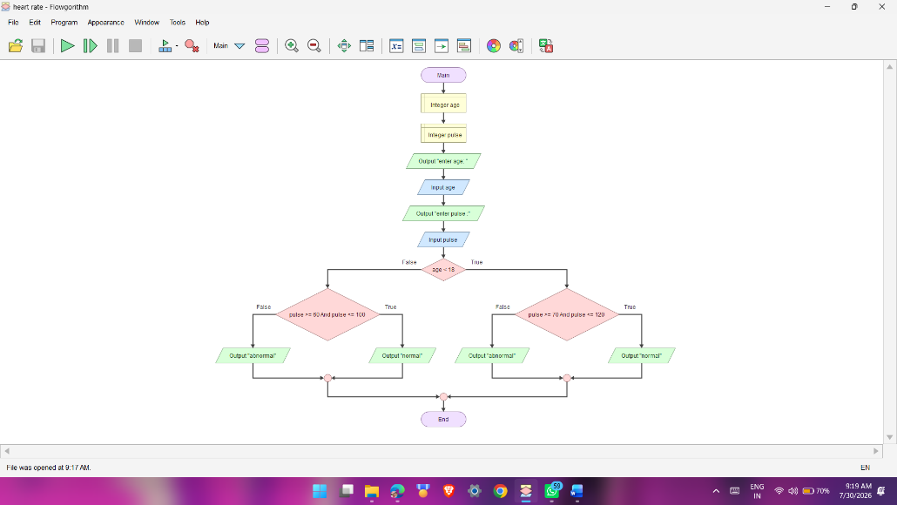
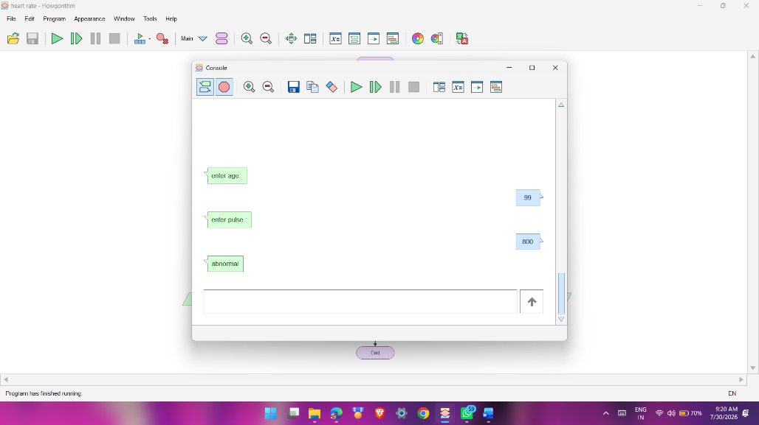

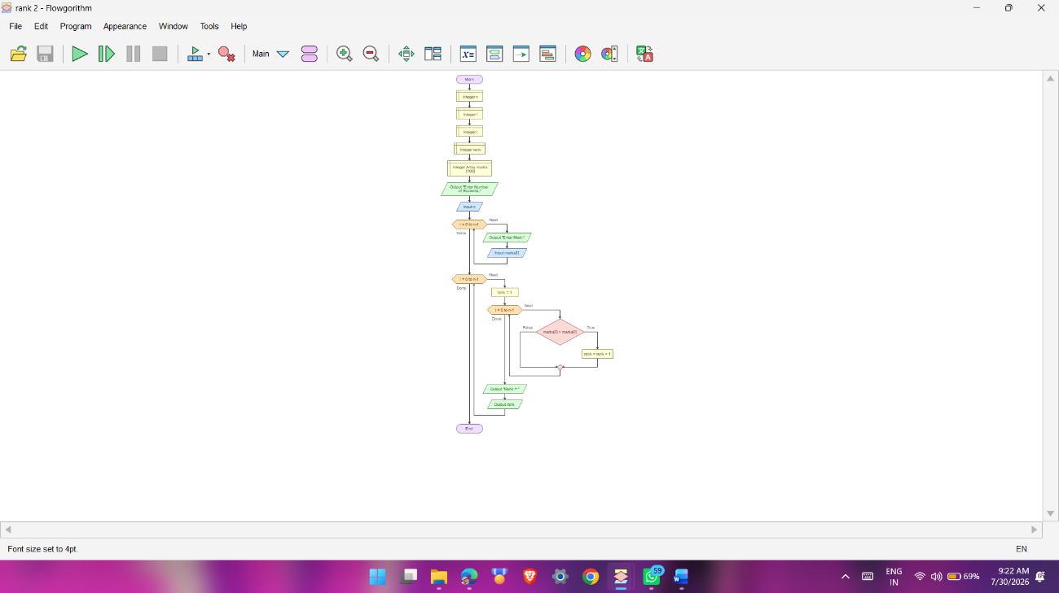
2. Read N student marks and display the rank position of each student based on descending marks, without using built-in sorting.
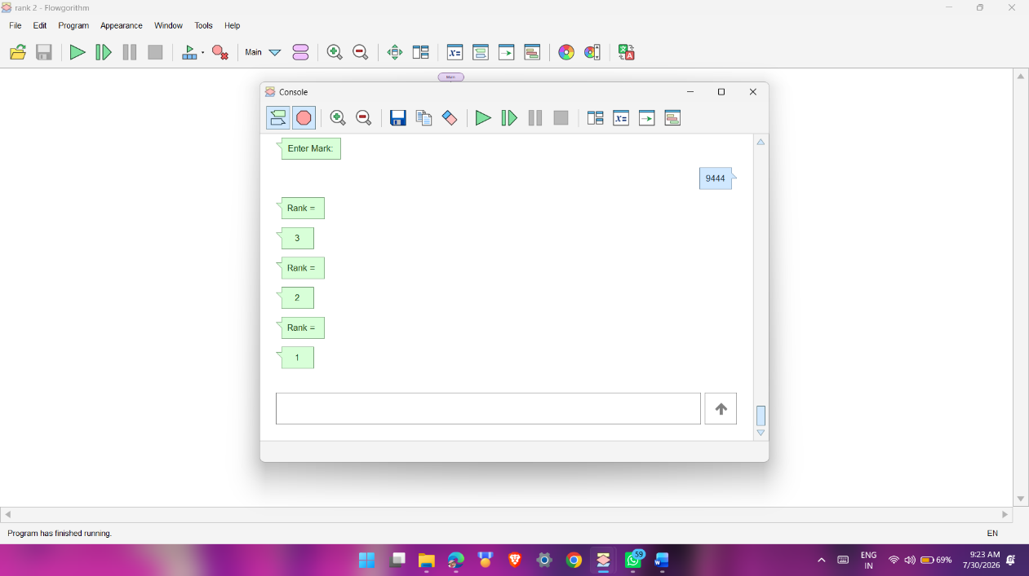

Create a function frequency that returns how many times a target occurs in an array, then use it to display the mode.
